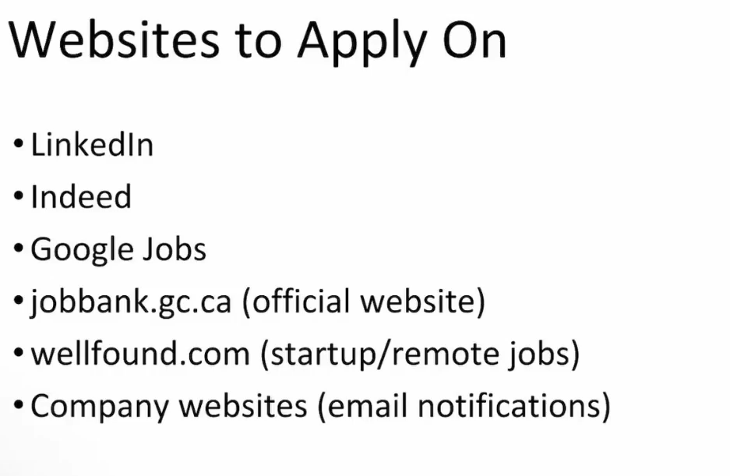
Use all, But best are LinkedIn and Google jobs. Because these 2 will give you direct link to company website.
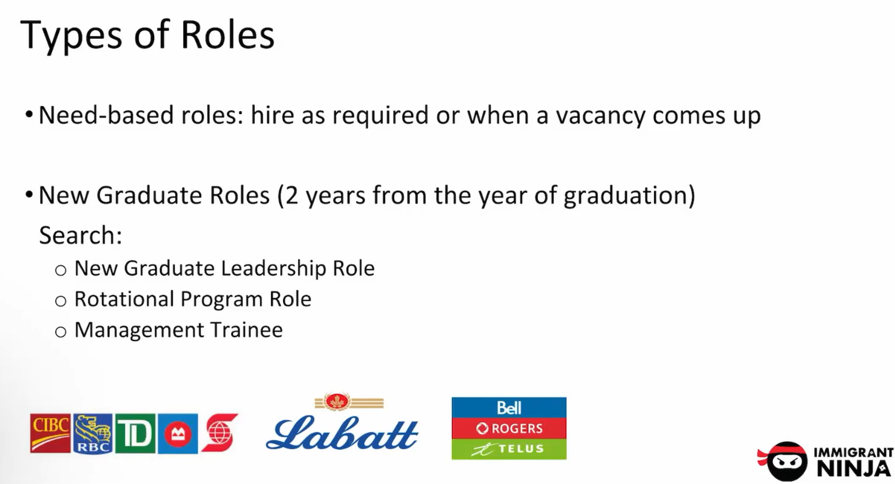
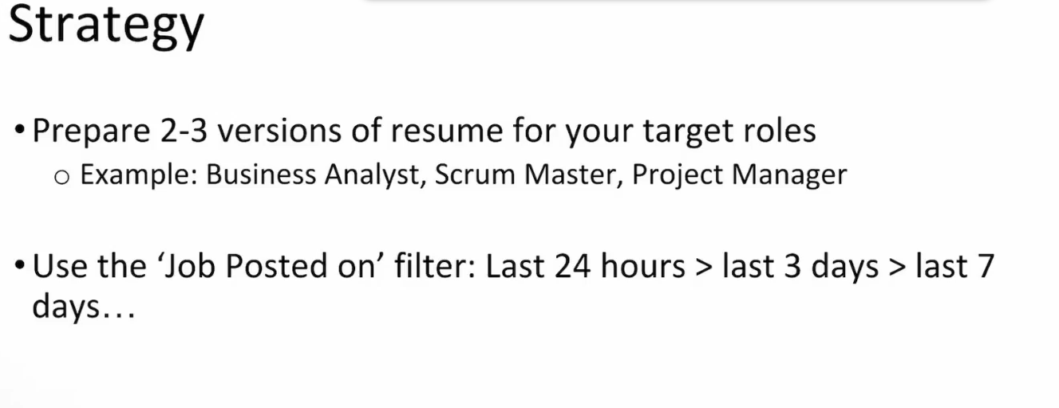
Be Consistent to your role @ JAVA DEVELOPER.
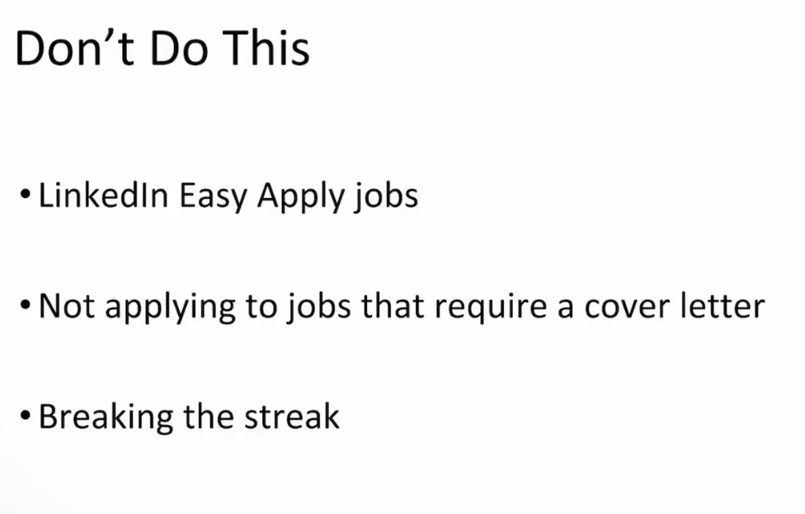

Stay consistent and apply don’t break streak

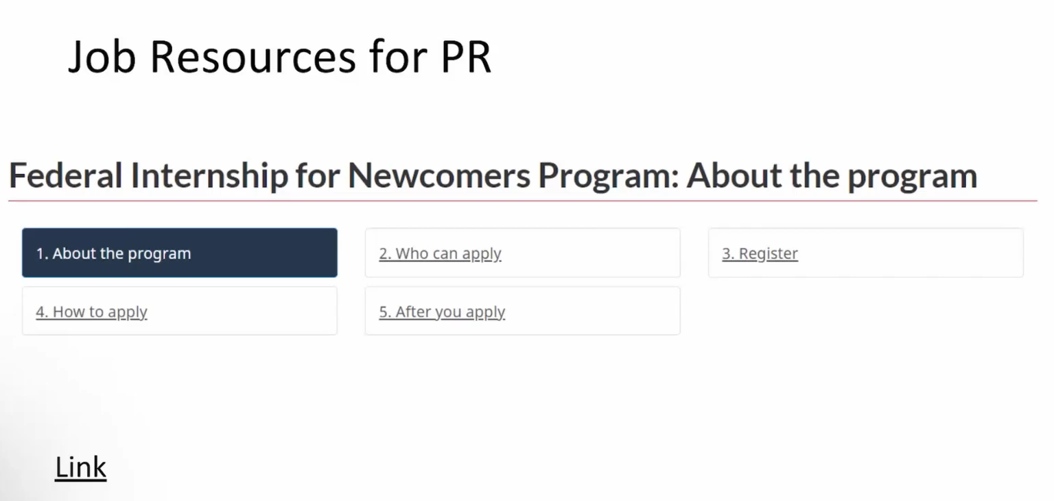
This website is for people who are PR here already.
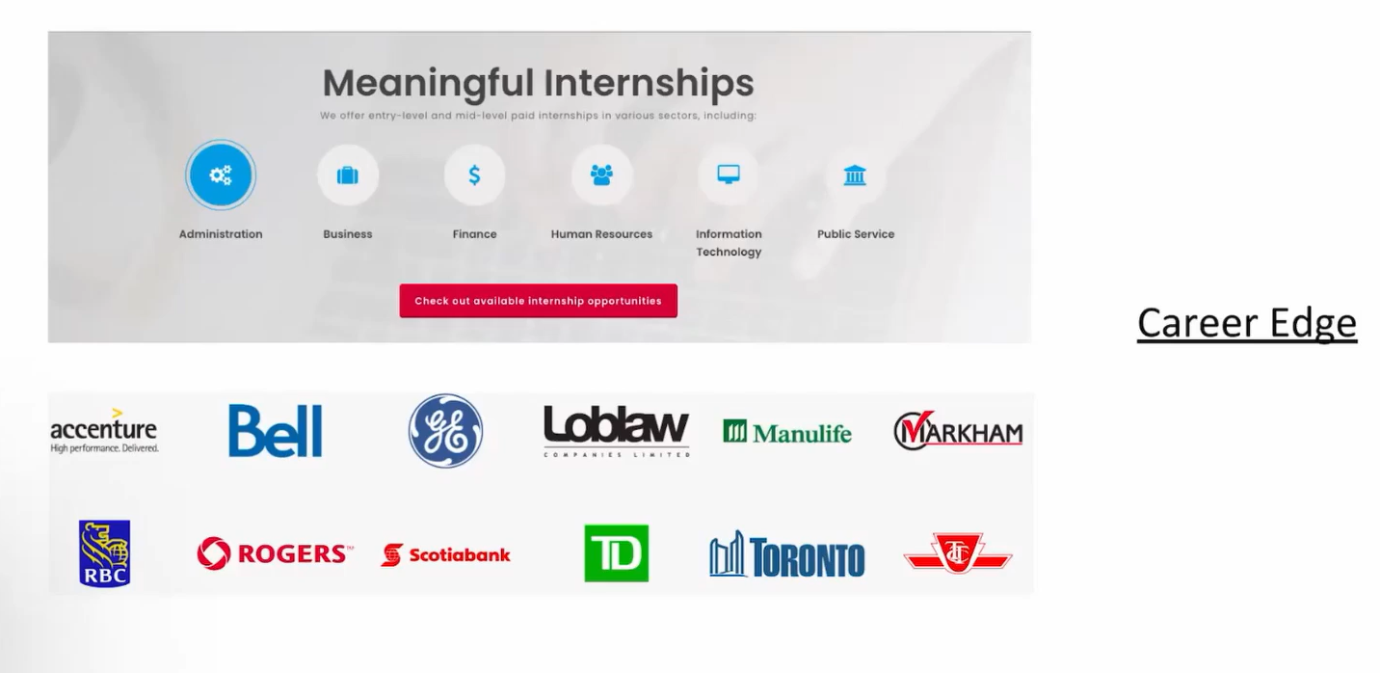
Here at Career Edge you will get internship and normal jobs.
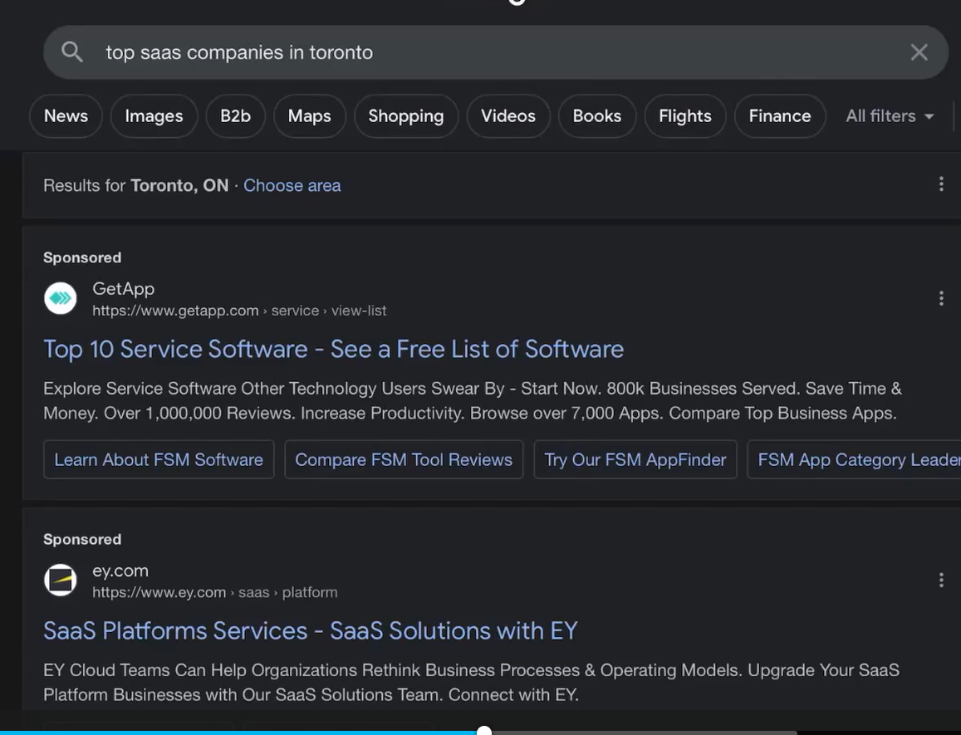
Search like: “ top java companies in Toronto.”
Now a list will come in browser, lets say one link shows you top companies for developer role.

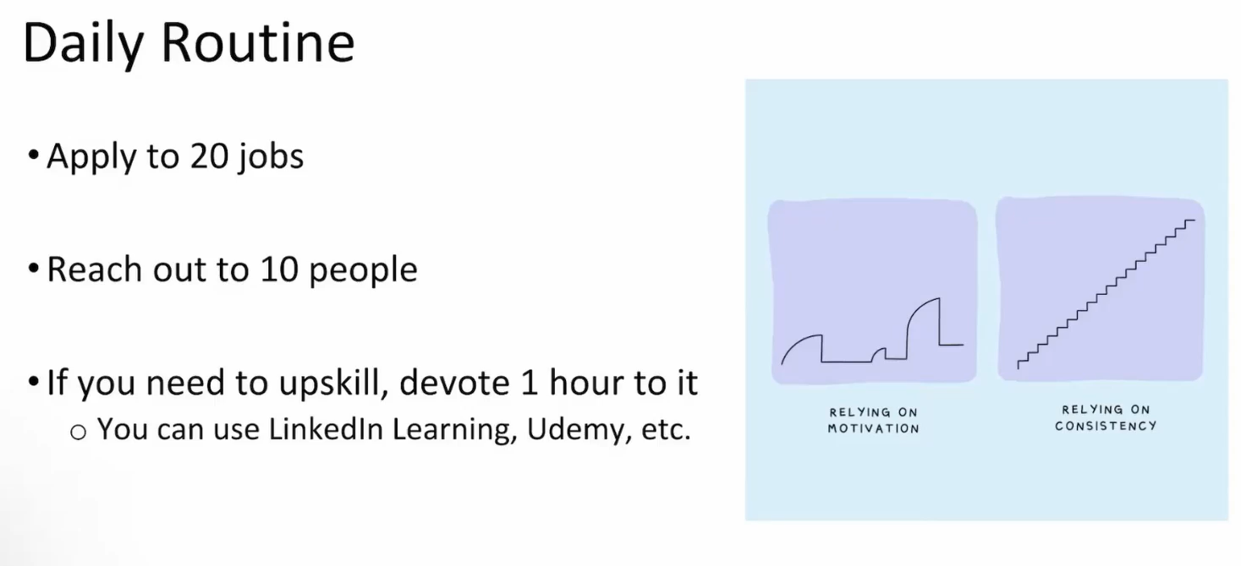
If you need job early triple these numbers for applying jobs.
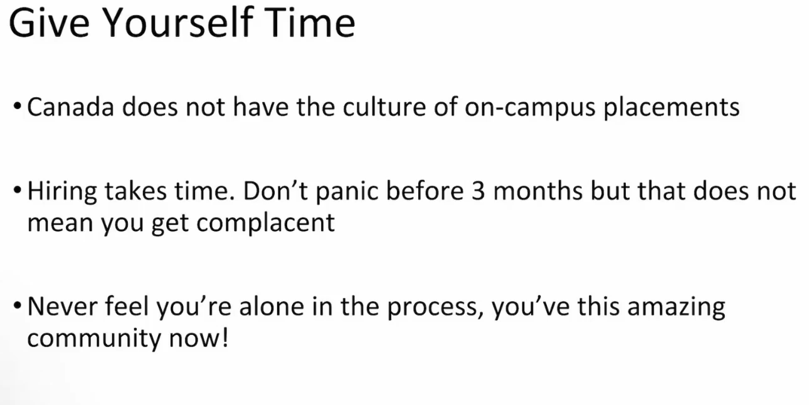

If you can not apply for 30 or 40 jobs a day then apply atleast 10 jobs.
Following are attached items for this lecture:
Action Items
Start applying
https://www.canada.ca/en/immigration-refugees-citizenship/services/new-immigrants/prepare-life-canada/prepare-work/federal-internship.html
https://www.careeredge.ca/for-job-seekers/

